**Problem Set 10 Electrostatics (Due 05/22/2025 before class)**

**Late homework will NOT be accepted, unless you have notified the course instructor 3 days BEFORE deadline.**

**Part I (60%)**

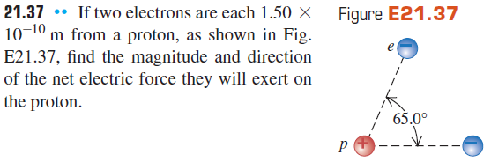

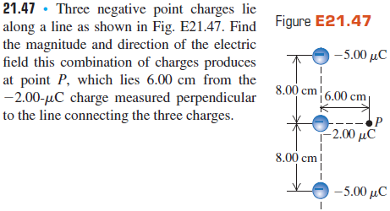

**Part II (40%)**

1. Determine the electrostatic force between the two charges of magnitude 2 C and -1 C separated by a distance 1m in air.
2. The distance between the two electrons in contact is equal to 1Å (0.1 nm). Determine the Coulomb force between them.
3. A point charge q1 = 2 µC located at origin and another point charge q2 = −5 µC is on the coordinate (x = 3, y = 4) m. Find the electric force on charge q1. Is the force attractive or repulsive?
4. Three point charges are fixed in place in the right triangle shown below, in which q1 = 0.71 µC and q2 = −0.67 µC. What is the magnitude and direction of the electric force on the +1.0 µC (let’s call this q3) charge due to the other two charges?

图示

AI 生成的内容可能不正确。

1. Three point charges are located at the corners of an equilateral triangle an in the figure. Find the magnitude and direction of the net electric force on the 7 µC charge.

图示

AI 生成的内容可能不正确。

1. What is the magnitude q of a point charge whose E-field at a distance of 25 cm is 3.4 N/C?
2. A small charge (q = 6.0 mC) is found in a uniform E-field (E = 2.9 N/C). Determine the force on the charge.
3. What is the value of the electric field at point C (see figure below)? Points A and B are point charges.

图示

AI 生成的内容可能不正确。

1. Which among the following statements best defines a dipole?

a) Combination of two like and unequal charges positioned at the origin

b) Combination of two unequal and like charges placed at the origin

c) Combination of two equal and opposite charges separated by a small distance

d) Combination of two unlike and unequal charges parted by a large distance

1. 3 C and -3 C are two equal charges separated by a distance of 4 cm, then calculate the dipole moment of a dipole.